***Application Security and Server-side Dev Course Code: IT6036***

***Antony Jones***

***92019124.***

**Project: Secure Web App**

**Group Contract**

|  |  |  |
| --- | --- | --- |
| Team Name  (PAZ) | Student Name | Student ID |
| Student 1: | Peter Seatter | 92060001 |
| Student 2: | Antony Jones | 92019124 |
| Student 3: | Zaine Woolf | 92060054 |
| Agreement Date: | 14/04/2020 |  |

# **Team Goals**

1. Some important values of the team would be:

* Reliability, Honesty, fairness by and to all members of the group throughout the project.

1. The goals of the team are as follows:

* Analyse and formulate requirements for a web application to solve a real problem.
* To communicate with each other, hold team discussions and record team decisions.
* Design a web application, including data access, UI and security design.
* Build and unit test a web application using a web framework.
* Perform user testing and security testing.

1. Team working skills required within the team:

* Collaborate effectively with others to plan, make decisions, design and build a web app.
* Use source version control to integrate your code with that of others.
* Reflect on team project experience and the decisions that were made within the group.

# Team Procedures

### Communication

|  |  |  |
| --- | --- | --- |
| **Team Name:** | **PAZ** | |
| Team Member Name | e-mail | Mobile phone |
| Peter Seatter | psea191@mywhitecliffe.com   | N/A |
| Zaine Woolf | zwoo191@mywhitecliffe.com |  |
| Antony Jones | ajon181@mywhitecliffe.com | N/A |

1. Outline how the group will communicate with each other.

The group will communicate mainly via the Microsoft team app and email communication. Also via an online Trello board to outline each team members workload, and for regular updates on progress and due to be completed dates.

1. Preferred methods of communication and how they will be used. How will you keep the team updated about your progress? (add, delete and revise as needed):

* Email: To be used for
* Group discussion board:

1. Face-to-face meetings / work sessions:

* (No face to face meetings to be held all meeting to be held on online application services like zoom and Microsoft Teams. Until regular attendance of course resumes)
* (also via team calendars.)

1. Asynchronous communication:

* Group members would be expected to check there emails and Trello board discussions at least every few days to keep up to date. And responses within the group to be reasonably prompt if circumstances allow?

1. Unavailability:

* If any group members know they will be unavailable for a specific date, please let other team member's know before hand.

1. Failure to communicate with group:

* Work will need to resume without the missing team member until the situation can be resolved.

### Roles of Group Members

Will group members be assigned specific roles? For example who will be the team leader, the time keeper, the facilitator and guardian of team rules (of this contract), the spokesperson, the recorder, etc. Note that it is advisable for you to take turns in each role. This could be split by days or by stages of the project.

|  |  |  |  |
| --- | --- | --- | --- |
| **Role (examples)** | **Team Member Name** | | |
| **First stage (specify dates)** | **Second stage (specify dates)** | **Third stage (specify dates)** |
| Team Leader | Peter Seatter 06/4/2020  (Change if needed) | Zaine Woolf  20/04/2020  (Change if needed) | Antony Jones  25/04/2020  (Change if needed) |
| Facilitator / Guardian of Contract | Antony Jones  13/4/2020  (Change if needed) | N/A | N/A |
| Spokesperson | Zaine/Peter  13/4/2020  (Change if needed) | Peter Seatter  20/4/2020  (Change if needed) | Antony Jones  25/4/2020  (Change if needed) |
| Recorder | Zaine  13/4/2020  (Change if needed) | Peter Seatter  20/4/2020  (Change if needed) | Antony Jones  25/4/2020  (Change if needed) |
| Time Keeper | Zaine  13/4/2020  (Change if needed) | Antony Jones  20/4/2020  (Change if needed) | Peter Seatter  25/4/2020  (Change if needed) |

## Decision Making

1. How will decisions be made?

* Decisions will be made by majority vote as this would be better for the team environment. Decisions Can also be done by the team leader whoever allocated team leader at that particular time.
* Methods outlined below will be considered when making decisions in the team environment -

|  |  |
| --- | --- |
| ****Decision by authority**** | The group generates ideas and holds open discussions, but the final decision is made by one person. |

|  |  |
| --- | --- |
| ****Decision by negative minority**** | The group holds a vote for the most unpopular idea and eliminates it. They repeat this process until only one idea is left. |

|  |  |
| --- | --- |
| ****Combining ideas**** | Instead of dropping one idea in favor of another, the group searches for possibilities of implementing both or combining them into one solution. |

|  |  |
| --- | --- |
| ****Decision by consensus**** | All members agree that the decision is acceptable. Each member to select one of the following responses:  1. I can say an unqualified “yes” to the decision.  2. I find the decision acceptable.  3. I can live with the decision, but I’m not especially enthusiastic about it.  4. I do not fully agree with the decision, but I do not choose to block it.  5. I do not agree with the decision, and I feel we should explore other options. Discuss until all answers are 1, 2, 3, or 4. |

1. How will decisions be recorded?

* The team will Record the group decisions within the discussion channels. Example - Trello board, or Microsoft Teams chats etc.

1. How will conflicts and disagreements be resolved?

By the use of -

## Interpersonal skills

Effective skills for communicating and relating to others include:

* Encouraging and supporting other group members
* Active listening
* Constructive disagreement
* Conflict resolution
* Consensus building

****Tips to encourage equal participation****

* If one person tends to dominate the conversation, use talking rounds where each person is given the same amount of time to speak, sometimes holding some object to emphasize whose turn it is. Do this until you get used to equal participation.
* Make sure each person in the group has a specific role in the discussion, such as: time keeper, recorder, facilitator. Take different roles for the next discussion.
* Begin and end a discussion or meeting with each person taking turns to talk.

## Record Keeping

1. How will you save evidence of team discussions and team decisions?

* Evidence of team discussions and team decisions will be recorded via -
* Microsoft teams chat room.
* Trello boards.
* Reflective Journal.
* Reflective journal that all team members will keep -
* 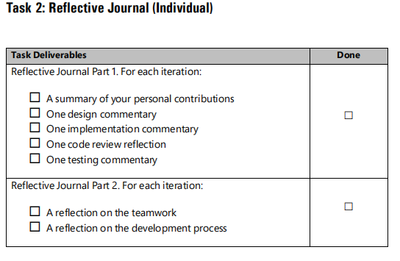

**Stand-up Meetings**

It is recommended that you hold **short daily Stand-up Meetings** every day to check on tasks

completed, next tasks and any road-blocks (look up “Scrum Stand-up meeting” to find out more.)

Make sure that each team member takes a turn running the meeting.

IT6036 Application Security & Server-Side Development Project

Whitecliffe IT6036_Project_SecureWebApp_v1c 7

Each team member should update the team on :

1. Work you have completed since last meeting

2. Unresolved issues that prevent or slow down your progress

3. Work you intend to complete by the next meeting

Remember to set yourself small achievable goals from one meeting to the next. See SMART Goals

section of the Professional Practice course.

1. How will you save evidence of each member’s contributions to the project?

Each team member’s contributions will be recorded by themselves via a -

**Reflective Journal (Personal Journal Entries)**

This will include the following -

A summary of your own personal contributions Example -

1. Team roles
2. Task you completed
3. Your contributions to the group discussions
4. Your contributions toward group decisions

# Team Expectations

# Behaviour Expectations

1. List the behaviour expectations (e.g. regarding punctuality, preparation for meeting, timeliness of contributions, input to discussions, etc.)

Team members will:

* Be punctual
* Prepared for meeting
* Willing to participate

1. How will you handle disagreements about team member behaviour?

* Any disagreements within the team should be first dealt with within the group to fix any problems the team may face. Any further unresolved issues should be passed on to instructors of CPP for help resolving the issues within the team.

## Team Participation

1. Preference for leadership (informal, formal, individual, shared):

* Make sure each person in the group has a specific role in the discussion, such as: time keeper, recorder, facilitator. Take different roles for the next discussion.

1. Strategies to ensure cooperation and equal distribution of tasks:

* Encouraging and supporting other group members
* Active listening
* Constructive disagreement
* Make sure each person in the group has a specific role in the discussion, such as: time keeper recorder, facilitator. Take different roles for the next discussion.

1. Strategies for encouraging/ including ideas from all team members:

* Encouraging and supporting other group members
* Active listening
* Constructive disagreement
* Conflict resolution
* Consensus building
* If one person tends to dominate the conversation, use talking rounds where each person is given the same amount of time to speak, sometimes holding some object to emphasize whose turn it is. Do this until you get used to equal participation

1. Strategies for keeping on task:

* Make sure they **understand the value** of what the team is doing, and of current objectives.
* **Set expectations**. Make sure team members understand the need and buy into doing their share. Show them everyone else is doing their part.
* **Listen**. Everyone should get a voice in team.
* **Encourage Team Member's.** Make sure to encourage others and build up.

# Dealing with Issues

## Non-Cooperative Team Members

1. How will you deal with non-cooperative team members?

****Guidelines for dealing with non-cooperative group members****

* If a group member refuses to cooperate on the assignment, the group should meet with the tutor so that the problem can be resolved, if possible.
* If the problem continues the group members may notify the uncooperative member that they are in danger of being let go from the group. The tutor must also be notified at the same time.

(Felder & Brent, 2000)

1. What are the consequences for failing to follow procedures and fulfil expectations?

* If there is no improvement they should notify the uncooperative group member that they are no longer part of the group. The let go student must meet with the tutor to discuss their options. Students who are let go must find another group willing to work with them or worst case scenario could get no marks for the assignment.
* Alternatively a group may decide that a student who has not contributed to the assignment should not have his/her name included on the completed work.

(Felder & Brent, 2000)

# Timelines and Milestones

## Project Timeline

Project Secure Web App - Team Component

1. Create a timeline for the project.

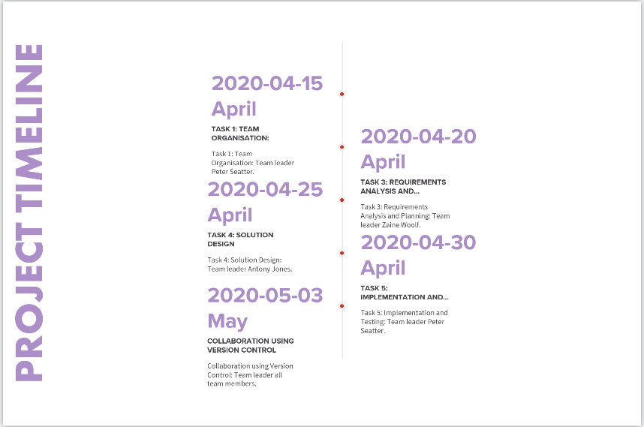

* Task 1: Team Organisation:

Team leader Peter Seatter.

2020-04-15 April.

* Task 3: Requirements Analysis and Planning:

Team leader Zaine Woolf.

2020-04-20 April.

* Task 4: Solution Design:

Team leader Antony Jones.

2020-04-25 April.

* Task 5: Implementation and Testing:

Team leader Peter Seatter.

2020-04-30 April.

* Collaboration using Version Control:

Team leader all team members.

2020-05-03 May.

1. It can be challenging to predict how much time is needed for each stage prior to beginning a project. In this section outline how you will handle revisions to the timeline, if necessary.

Changes to the timeline are flexible and can be changed at anytime via a group meeting were all member's of the group are present and agree.

**Signed Form**

|  |  |  |
| --- | --- | --- |
| Student name | Signed | Date Signed |
| Peter Seatter | PESeatter | 15/4/2020 |
| Antony Jones | Antony Jones | 15/4/2020 |
| Zaine Woolf |  |  |